23.67: From Example 21.10, we have: 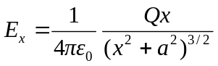
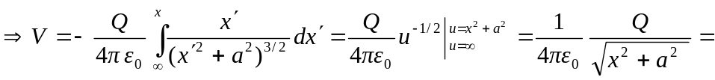Equation (23.16).

